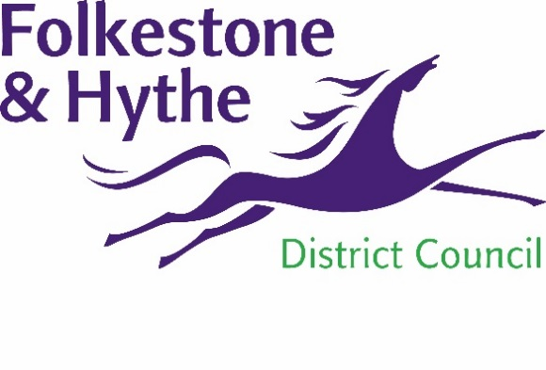
NEWS RELEASE

22 October 2020

VISIONARY PLACE PLAN FOR FOLKESTONE TOWN CENTRE
Folkestone & Hythe District Council is creating a visionary plan to proactively shape the future of Folkestone Town Centre.
The council is commissioning experts to engage with businesses, residents and visitors to inform the plan. The objective being to shape regeneration activity in the town and use the resulting recommendations to create a focused plan of action that can be adopted by all.
The Place Plan will acknowledge the history of the town, raise awareness of and support the vibrant cultural offer and growth potential of Folkestone as a place to live, work, invest and visit. Commissioned work will include identifying opportunities to build on the attributes of the town and propose development options which will deliver the ambition of the council’s planning policies and guidance.
Cllr David Wimble, Cabinet Member for the District Economy for Folkestone & Hythe District Council said: “Although we’re at an early stage the ambition of this Place Plan is very exciting. Folkestone is brimming with potential and we will do our bit to make sure that we are proactively engaging and using our influence to create a town fit for an extraordinary community that surrounds it.”
The council has released a tender this week for the commissioned work. Wider public engagement will take place in 2021.

Ends

Notes to Editors:
For more information, please email communications@folkestone-hythe.gov.uk

Follow us on Facebook: @FolkestoneandHytheDC
Follow us on Twitter: @fstonehythedc
Follow us on Instagram: @folkestonehythedc
Follow us on LinkedIn: Folkestone & Hythe District Council

